November, 2019 Reading Guide
Group 1
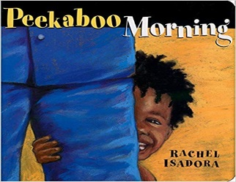
Peekaboo Morning is about a toddler that plays a game of peekaboo, and you're invited to play too. First there's Mommy to find, with Daddy not far behind. Then Puppy comes peeking around the corner, and a favorite toy train brings the toddler to Grandma and Grandpa.
Link to purchase https://www.amazon.com/Peekaboo-Morning-Rachel-Isadora/dp/0399251537
What are the benefits of play? Play allows children to use their creativity while developing their imagination, dexterity, and physical, cognitive, and emotional strength. Play is important to healthy brain development; in contrast to passive entertainment, play builds active, healthy bodies.
We will be making rainbow music shakers! With some colorful pom poms, rice, colorful ribbon, and a water bottle all group members will go home with their own musical instrument. Group will provide all necessary materials.
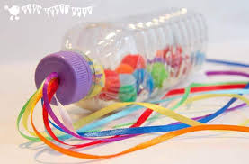
Suggested At-Home activities
Splish, splash
Water has such a joyful, relaxing effect on children — feel free to take advantage any time of the day. Your baby can go right in the tub (with you, if you’d like!) as you use your hands, sponges and funnels to splash water on different parts of his body. When your baby can sit up, spread a vinyl tablecloth on the floor and set out a shallow pan of water with lots of cups, sponges, spoons and maybe his own baby to wash. (Even with small amounts of water, never leave your child unattended during water play — not even for a second.)
Shake, rattle and roll
Fill empty water bottles with interesting things — rice, buttons, Jell-O, water mixed with liquid soap, food colouring or oil. (Be sure lids are tightly secured with packing tape and that your child can’t chew through the bottle.)

